# Project Report On

# Azure DevOps Tetris Game App Project

# Rahul Gajanan Dalavi

# Sandip Pralhad Gole

# Parth Shivraj Dalvi

# 

Magic Bus Foundation

Mulund (W)

**Summary**

The Azure DevOps Tetris Game App project involved the development of a classic Tetris game using agile methodologies and Azure DevOps tools. The project began with comprehensive planning, defining the project scope, requirements, and backlog of features.

Continuous Integration (CI) was implemented through Azure Pipelines, ensuring automated builds and tests. Azure Application Insights, ensuring a well-managed and optimized Tetris game app in the production environment. Through this approach, the team successfully delivered a high-quality Tetris game, meeting stakeholder expectations and user satisfaction.

In this project we have used **Azure services such as** **Container Registries, Docker Registry and App Services**.

**Aim: Azure DevOps Game App Project**

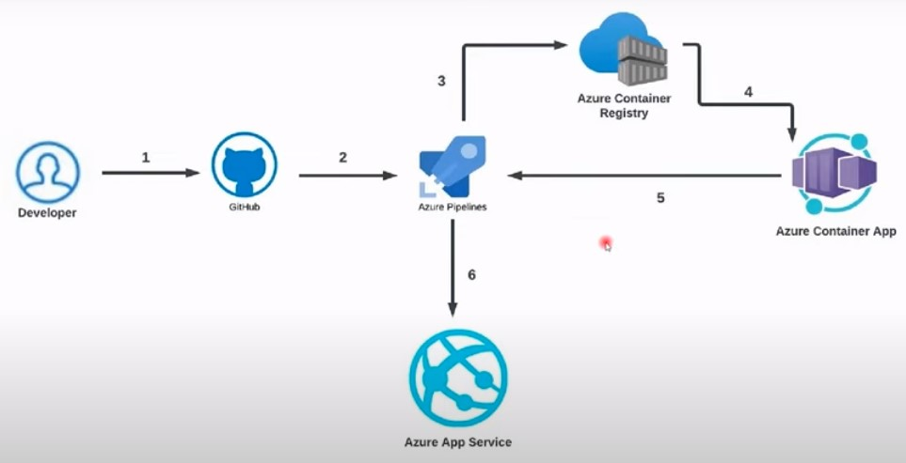

**Fig.1.1 Architectural Diagram**

* **Login to azure portal**

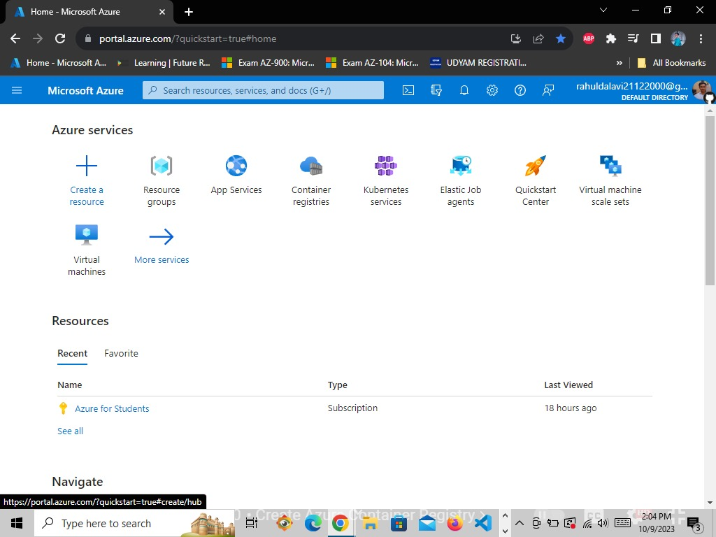

* **Go to Container registries & click on create**

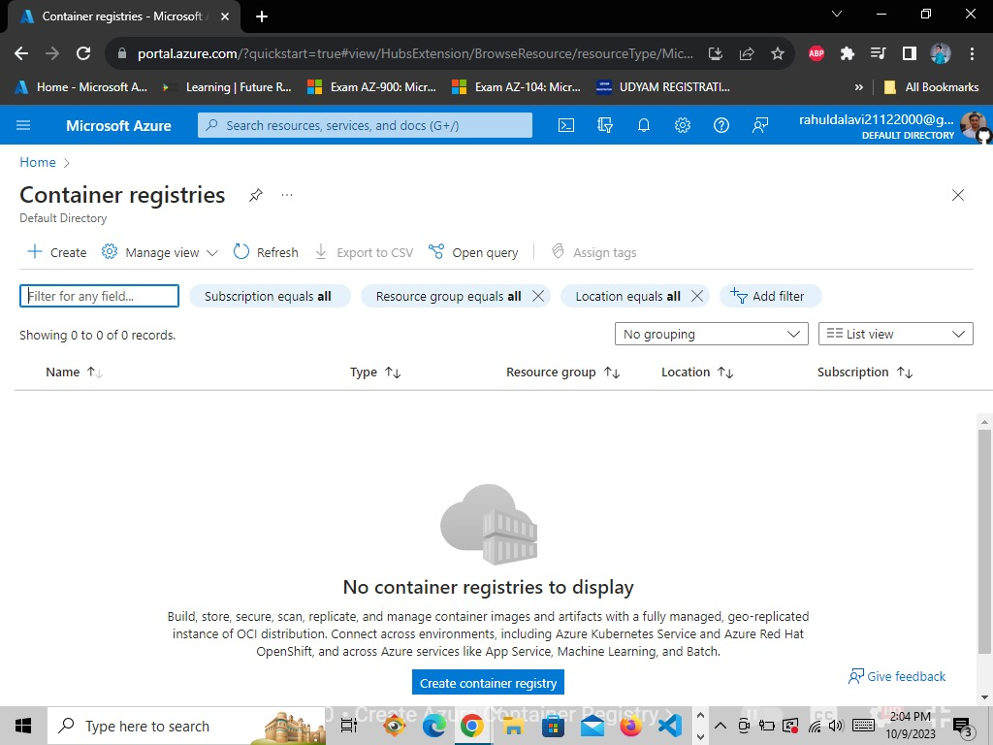

* **Fill the required fields Such as Resource Group, Registry name and location**

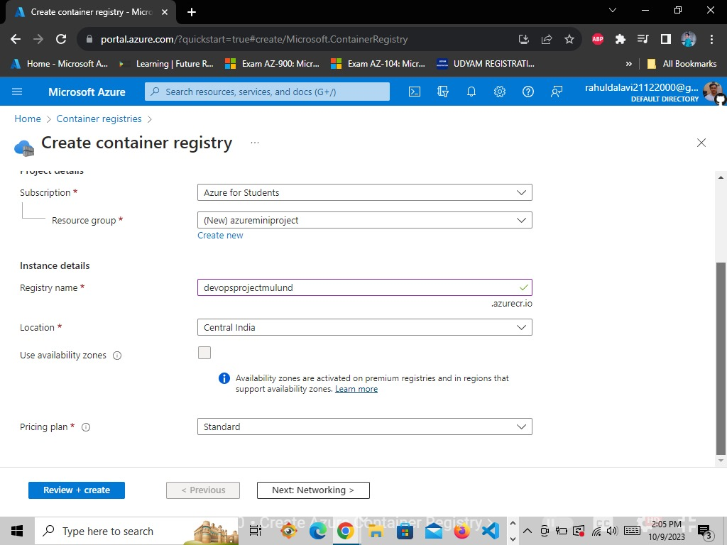

* **Click on Create**

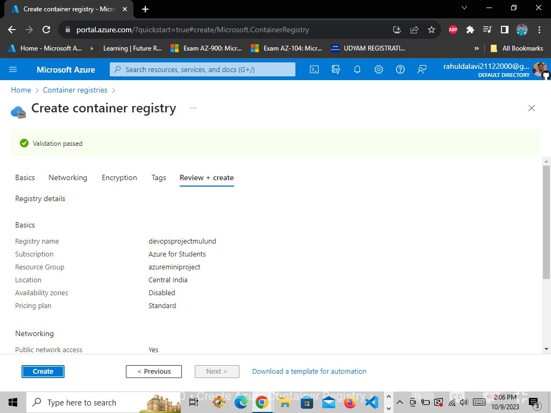

* **Here the container registries is successfully created.**

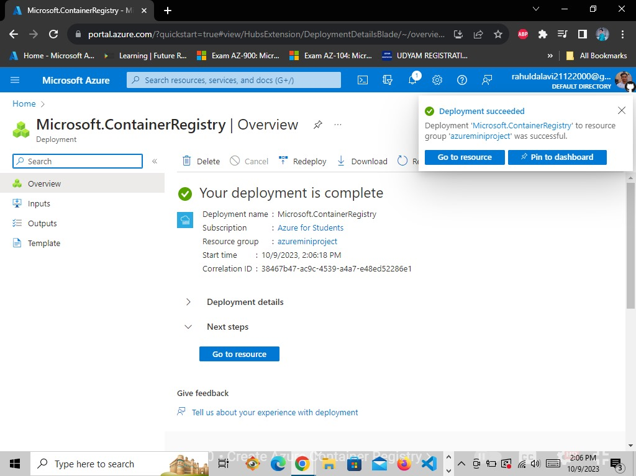

* **Now go to Azure DevOps Portal-> Create a Account and Login ->create a New Project in it.**

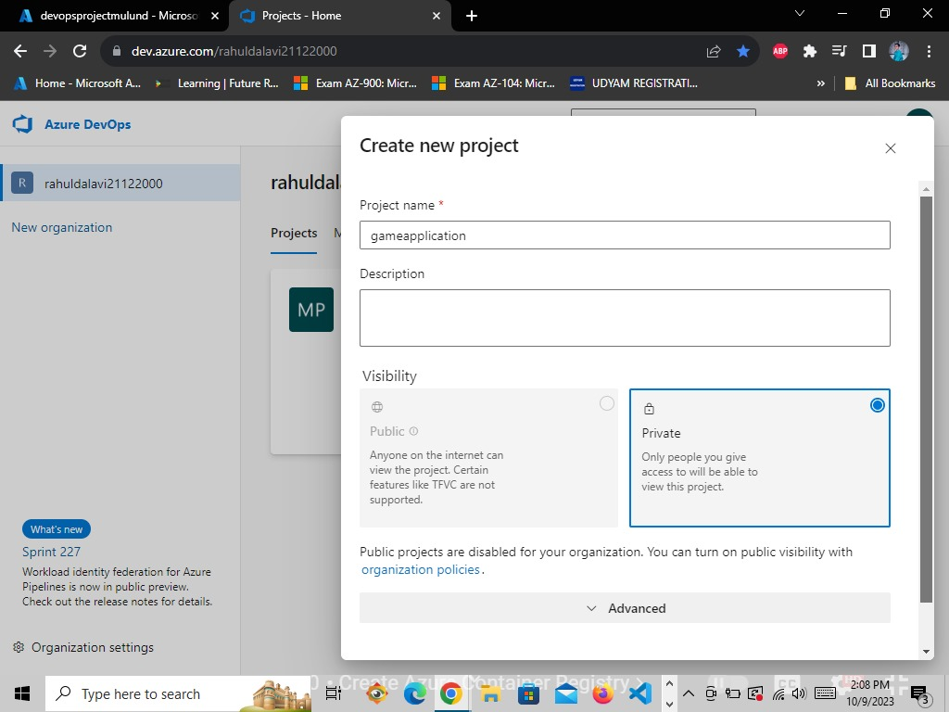

* **The project is created successfully**

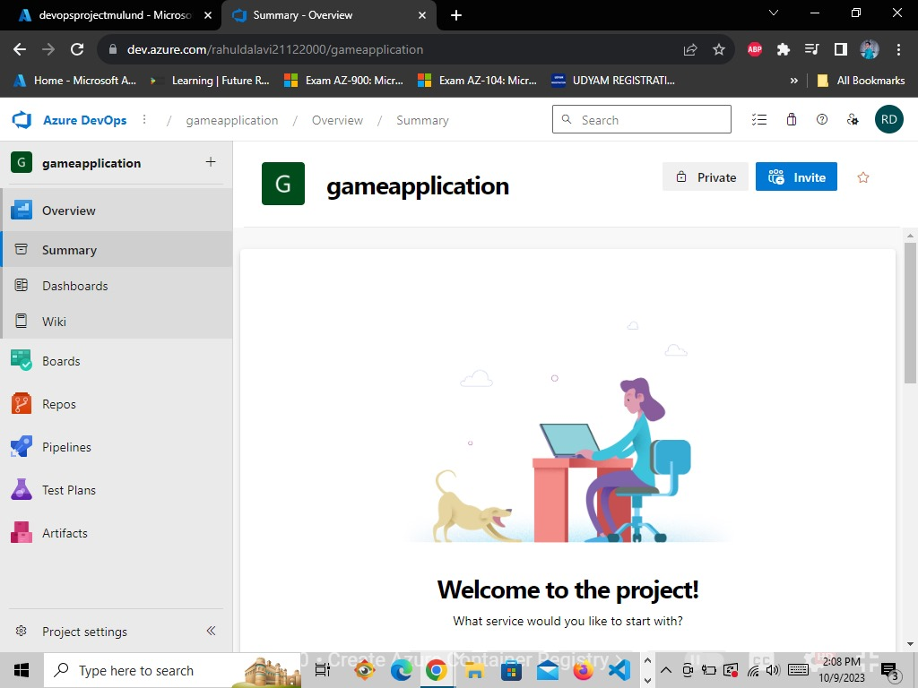

* **After creating the project -> go to project settings -> service connections and Create Service Connection**

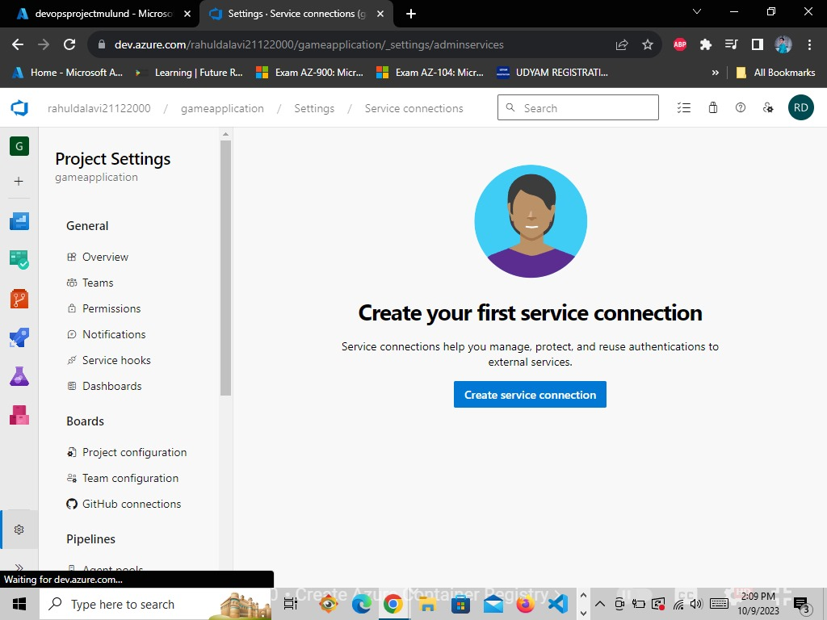

* **First we will Create a Docker Registry Service Connecion**

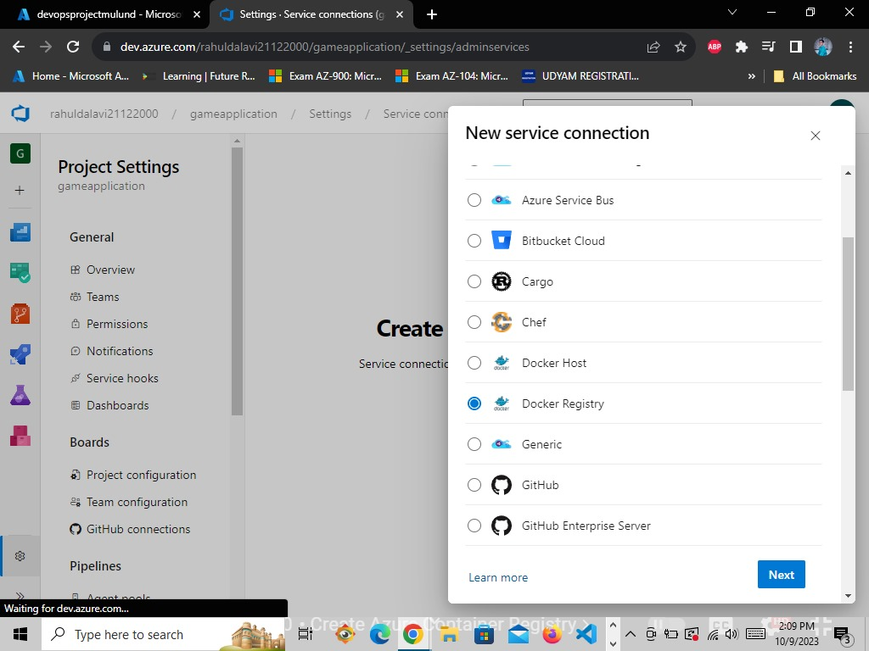

* **Select Azure Container Registry**

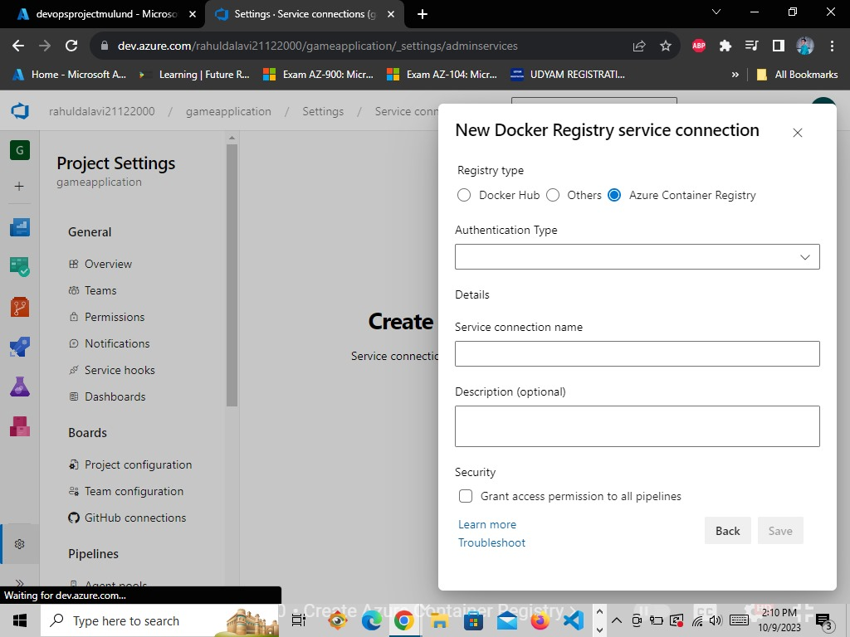

* **Select Service Principal**

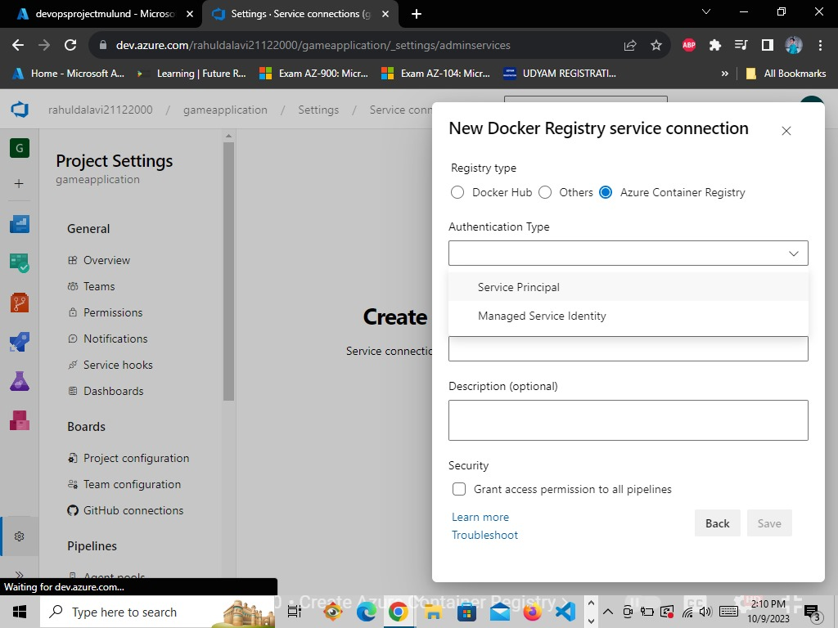

* **After selecting Service Principal it will connect us with our Azure portal.**

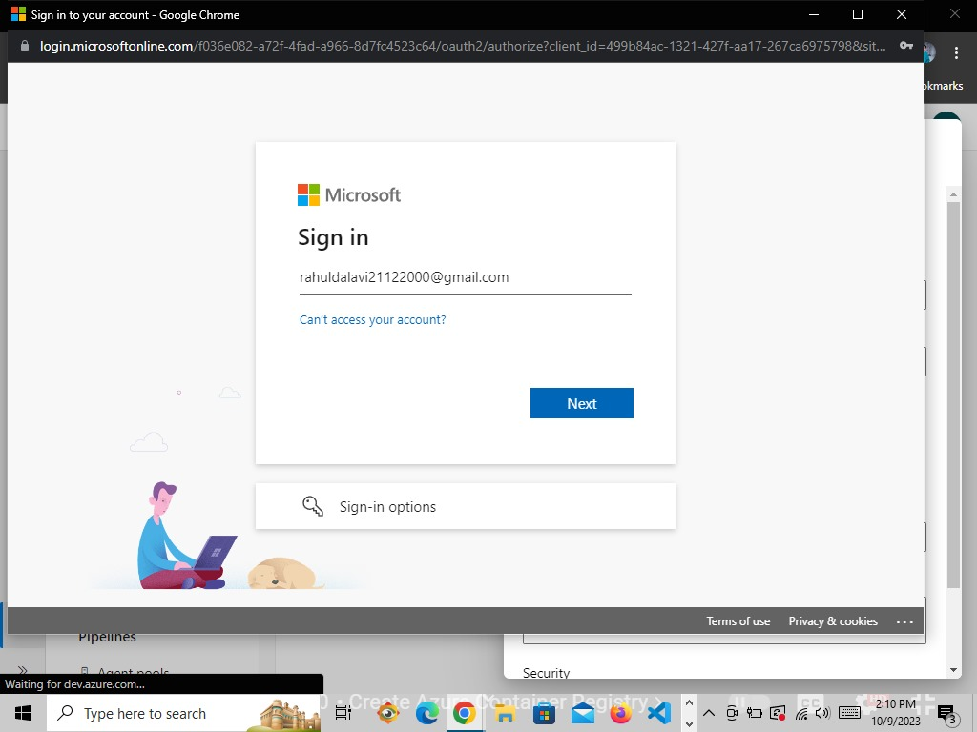

* **After connecting with the Azure Portal -> Select the container registry which you have created**
* **Now give the connection name, check the Grant access permission to all pipelines and save it**

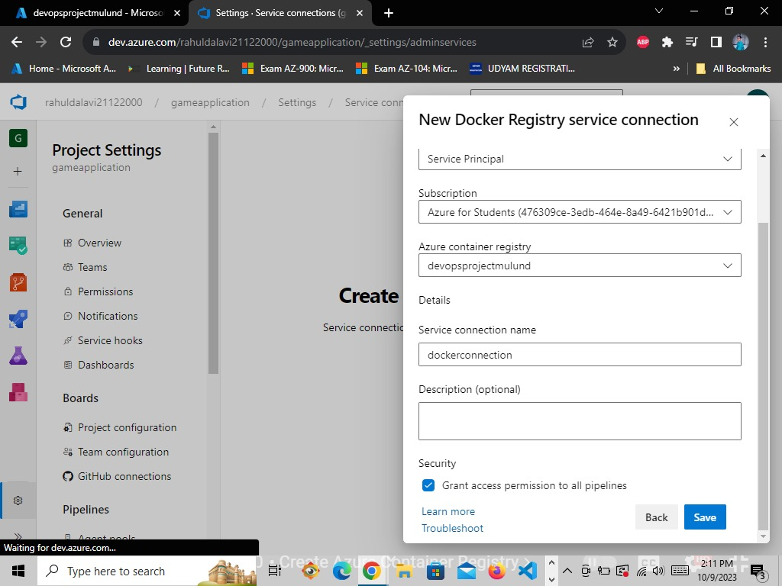

* **The Docker Service Connection is created successfully.**

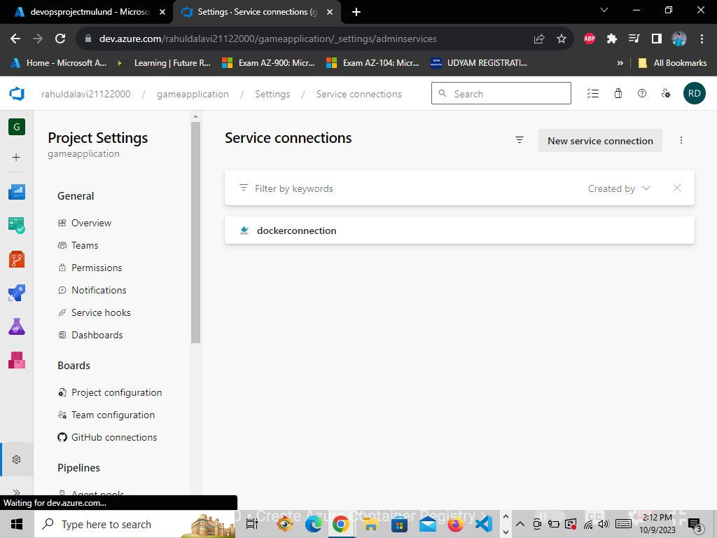

* **Now create one more service connection for GitHub.**

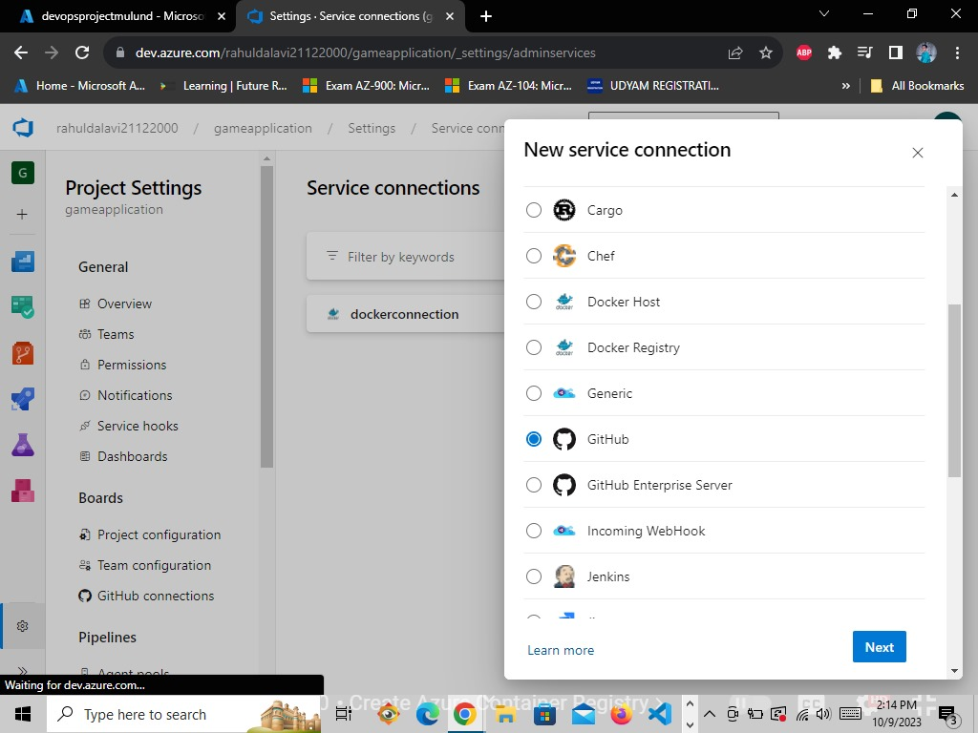

* **Select the Grant authorization Authentication method and the Select the AzurePipelines OAuth Configuration and Click on Authozie.**

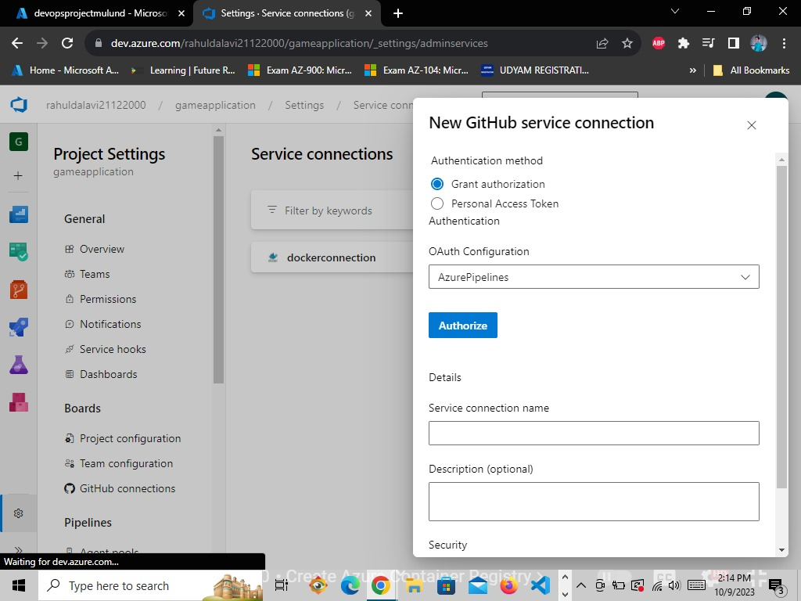

* **After clicking of Authorize it will tell us to Sign in on Github, click on next.**

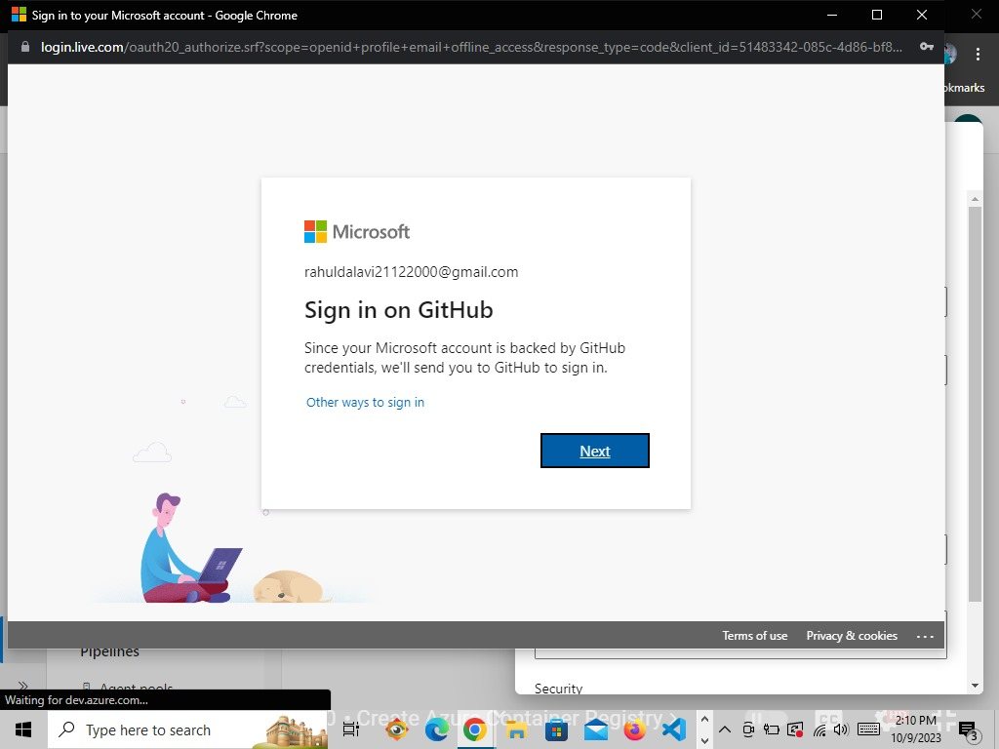

* **After Sign in with Github, Give the service connection name, check the Grant access permission to all pipelines and save it**

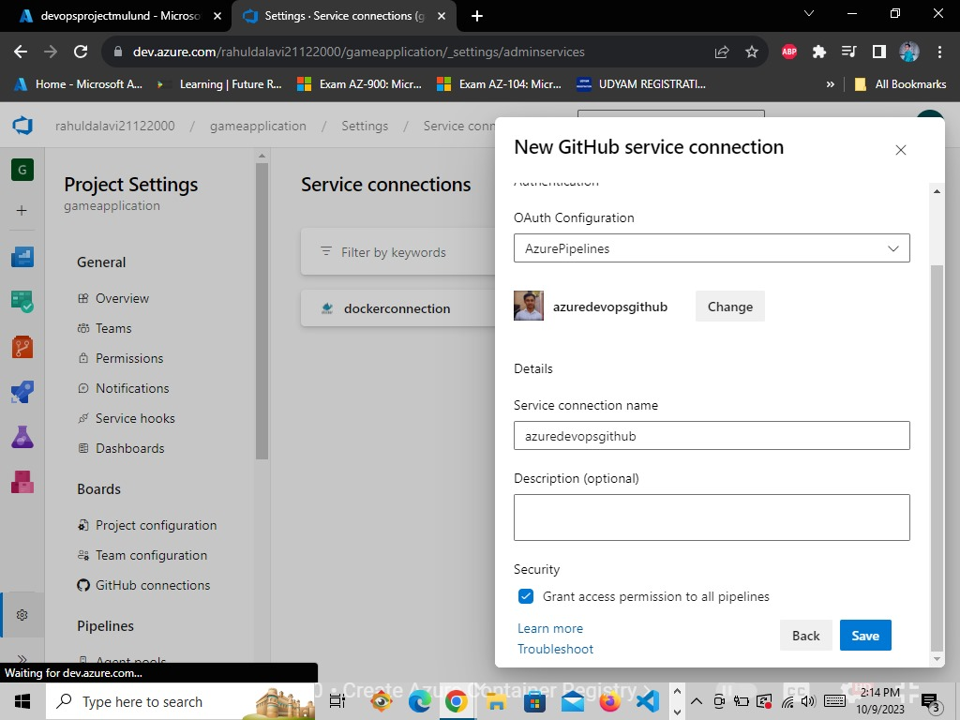

* **Now we have created both the service connections**

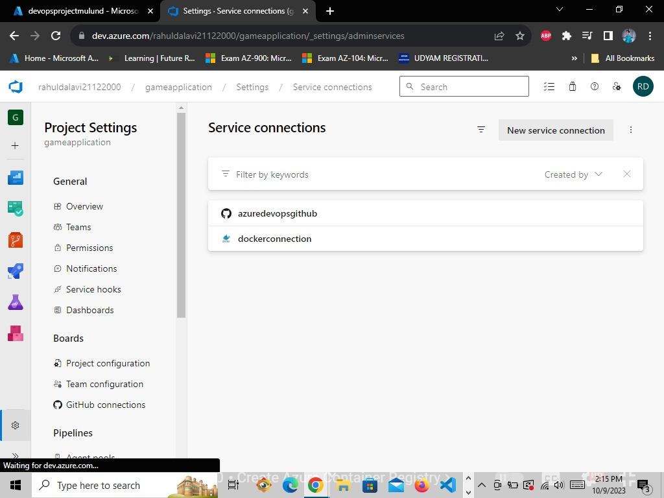

* **Now we will Create Build Pipelines**
* **In the Azure DevOps portal inside our project we will select pipelines -> Create a new Pipeline**

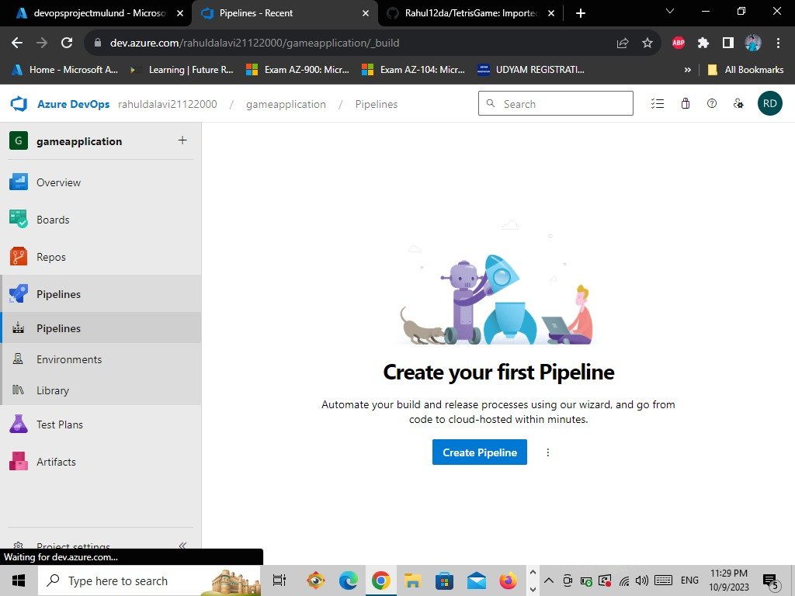

* **Select Github YAML**

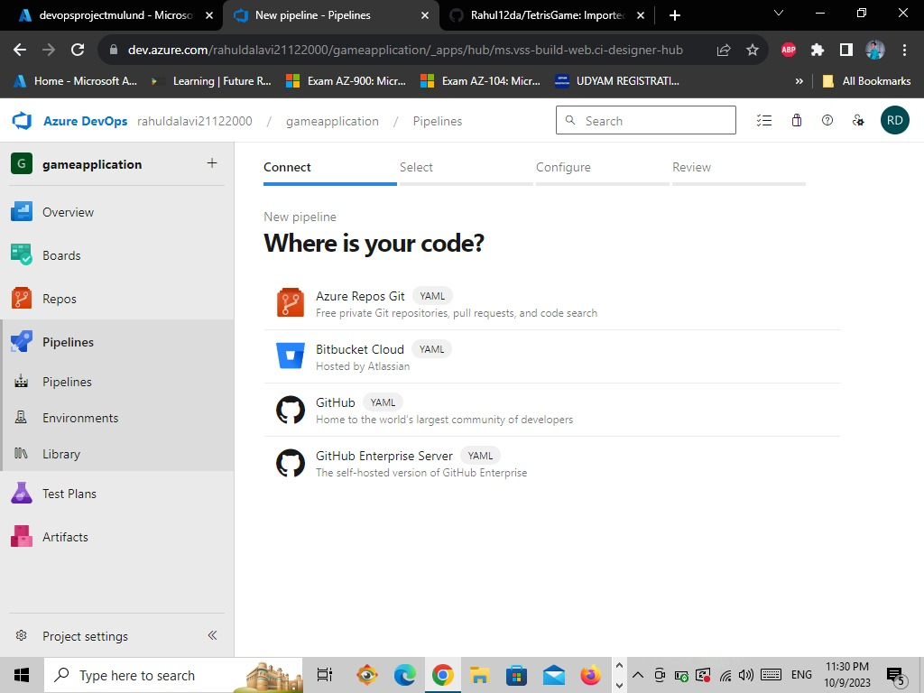

* **Then select the repository in which the game is there.**

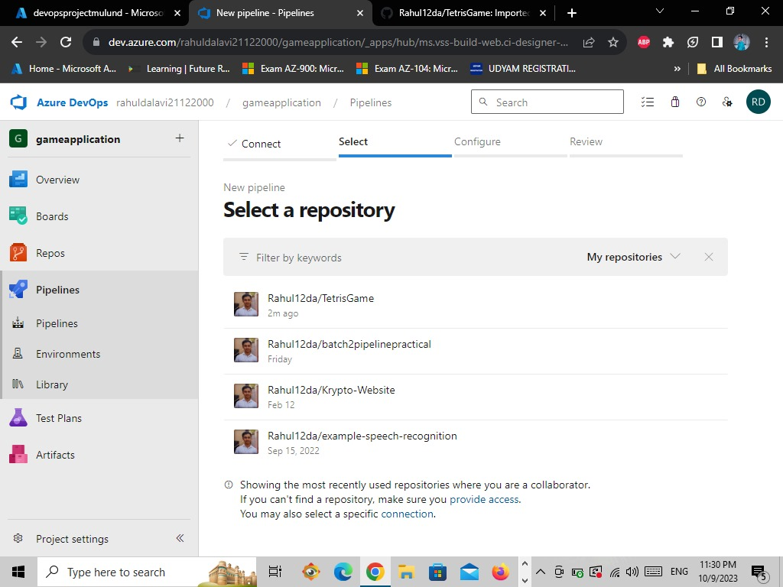

# It will redirect you to the github account to approval

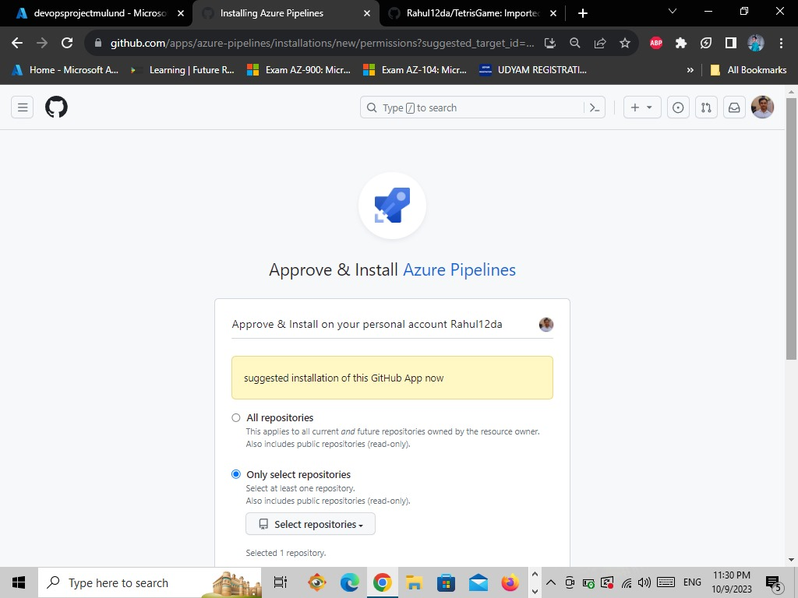

* **Now select Only select repositories and then tap on the Approve & install**

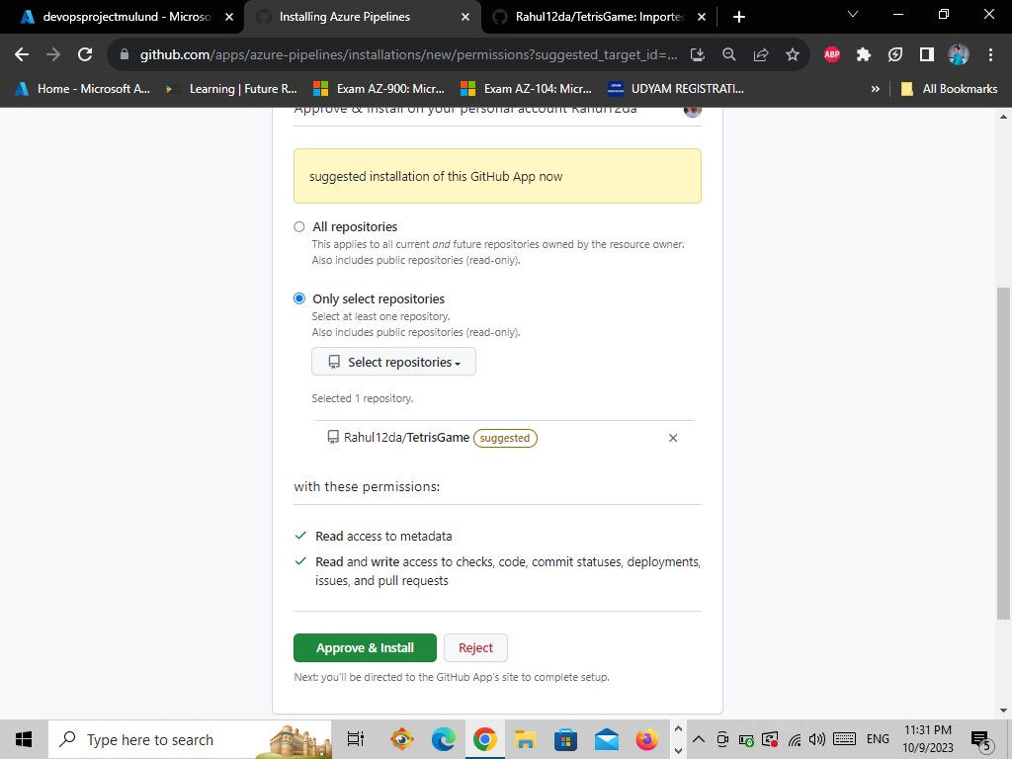

* **Enter github password and confirm**

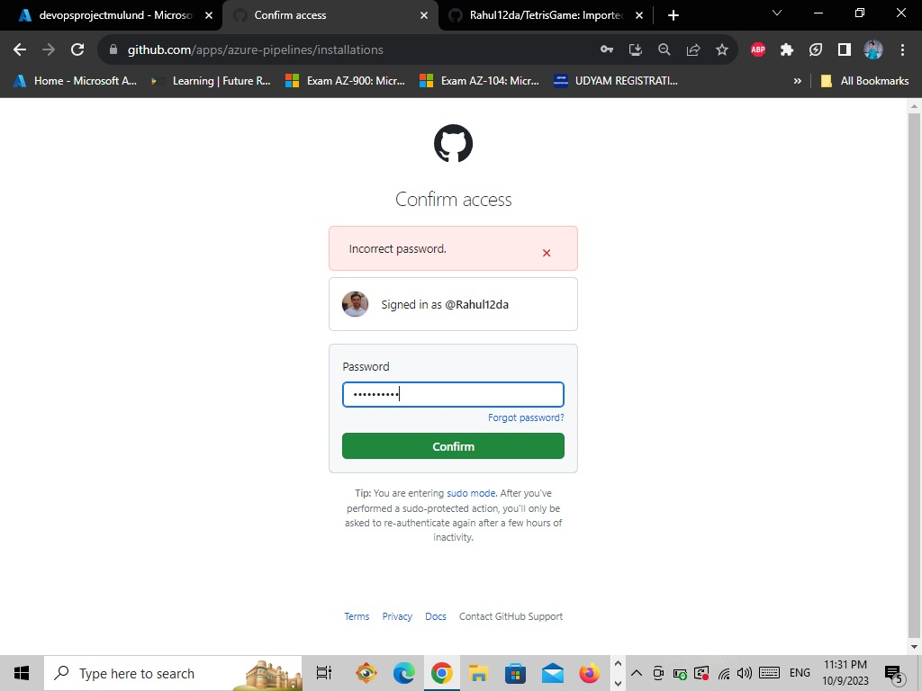

* **The page redirected to Azure Pipelines to continue installation**

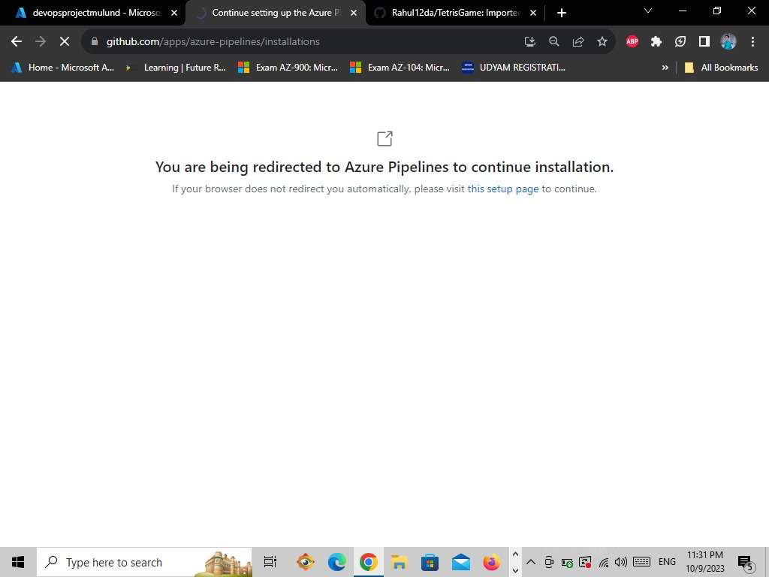

* **Then select the Microsoft account**

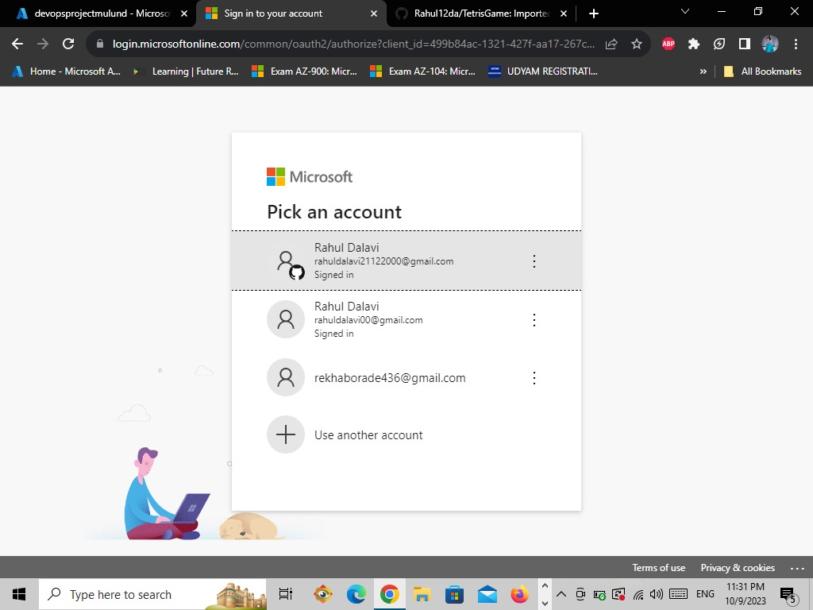

* **It will take you to Azure DevOps portal**

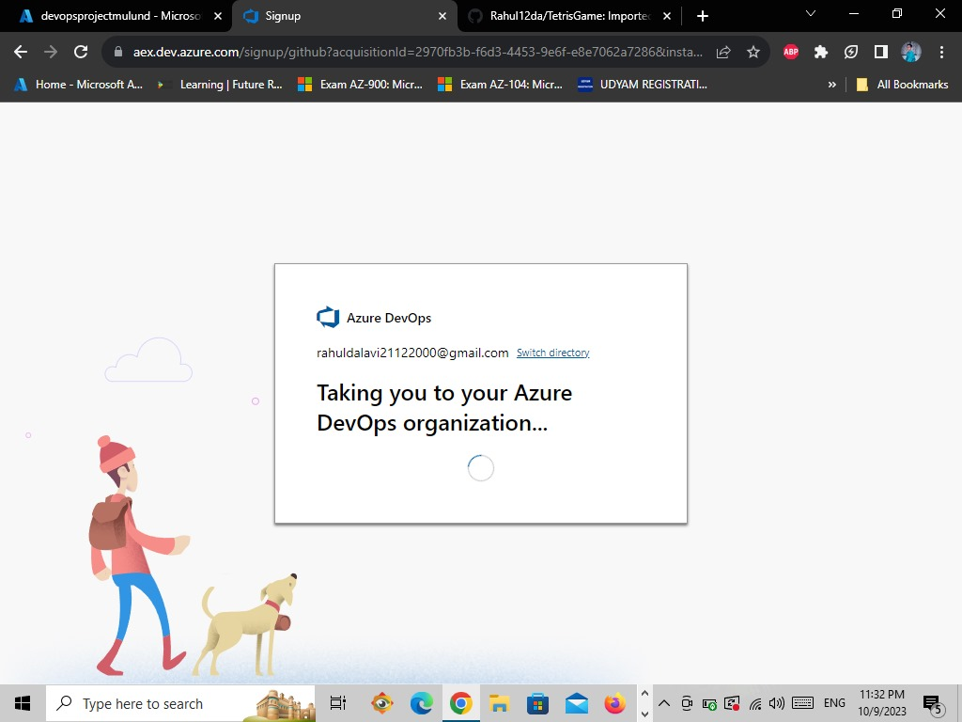

* **Then select Docker (Build and push and image to Azure Container Registry)**

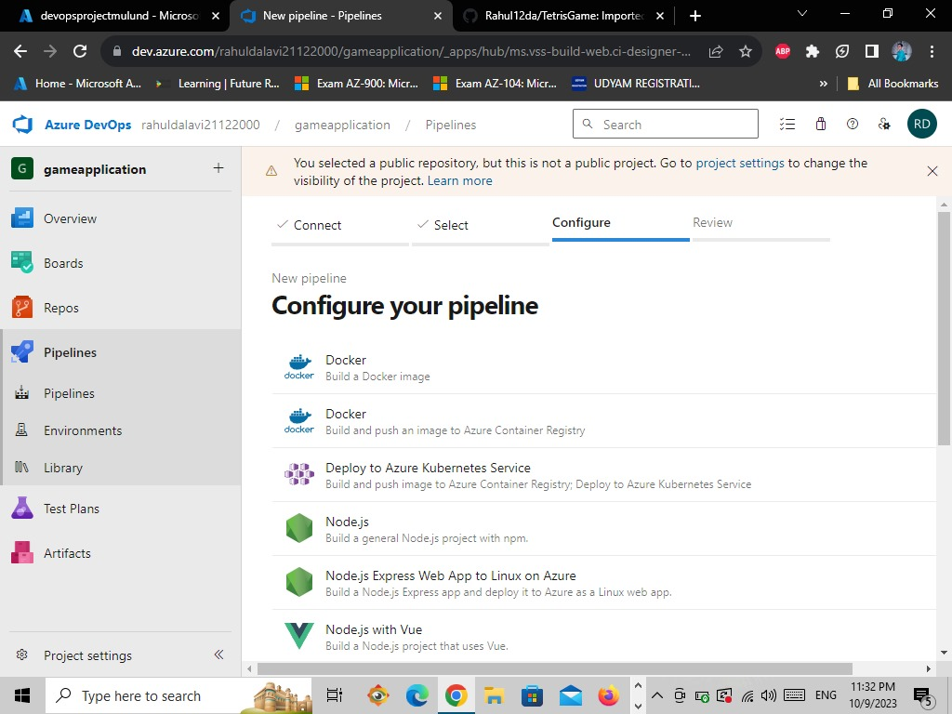

* **Select the Azure for students subscription and click on continue**

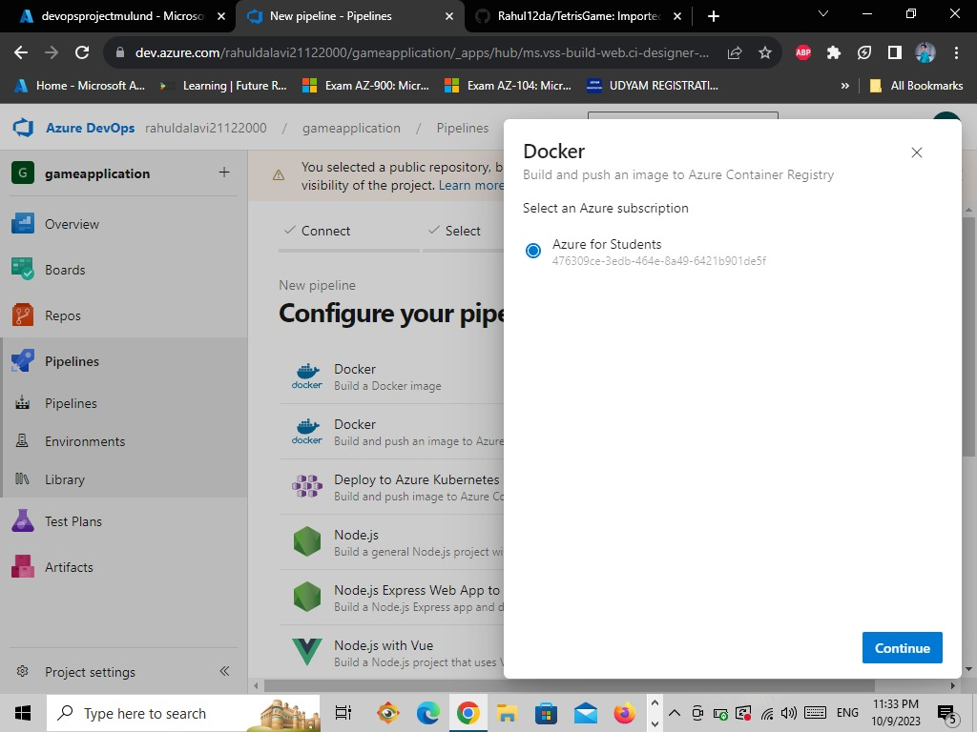

* **It will tell we to login, fill the credentials and login.**

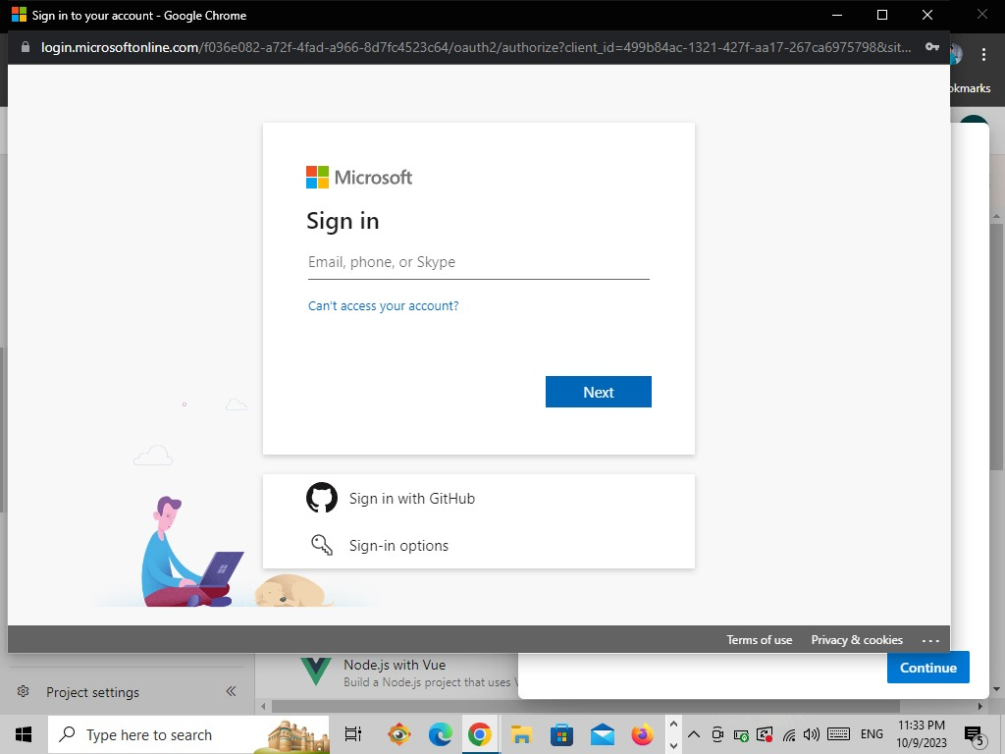

* **After logging in select the Container Registry -> give the Image name the click on Validate and Configure**

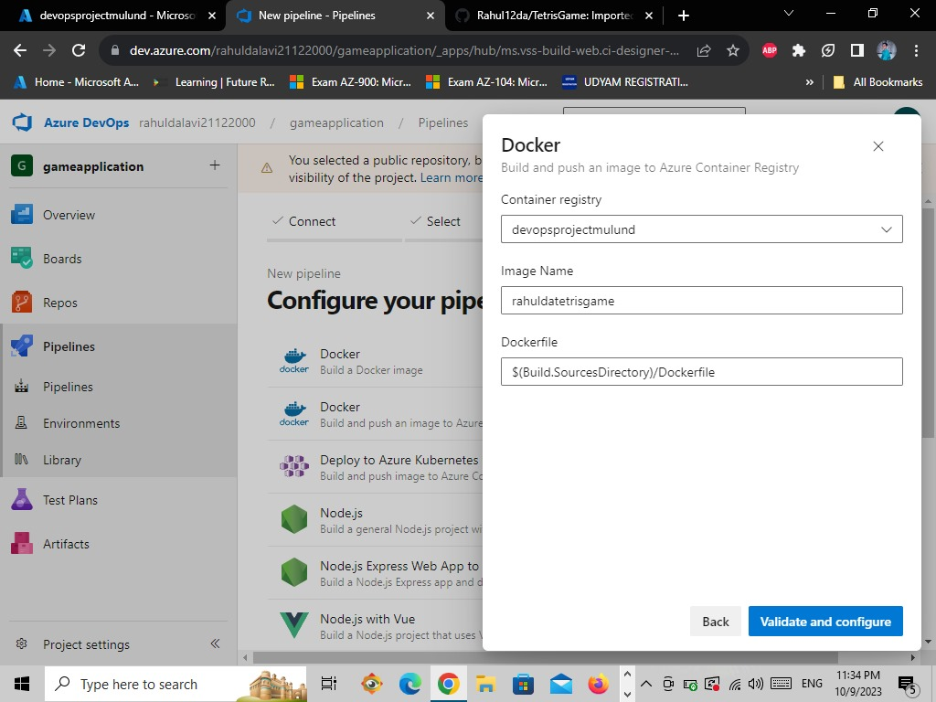

* **Now Click on Save and Run.**

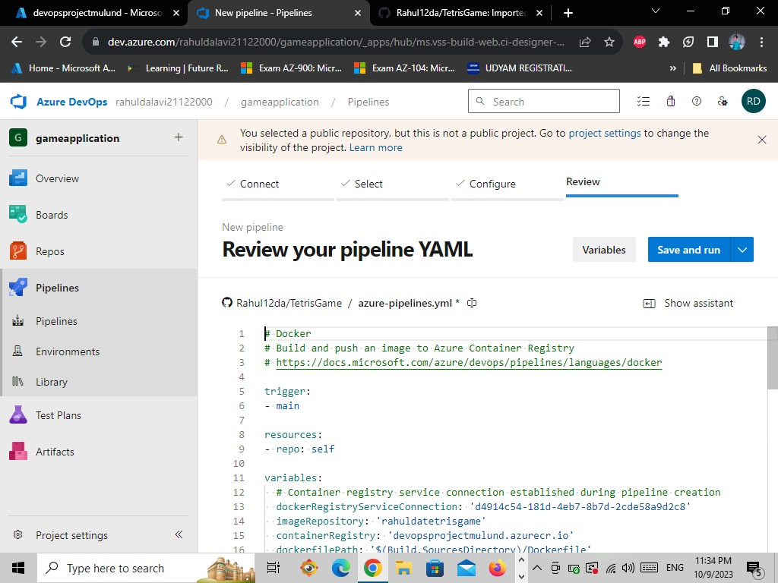

* **Enter commit message as Set up CI with Azure Pipelines select then commit directly to the main branch and then click on the save and run**

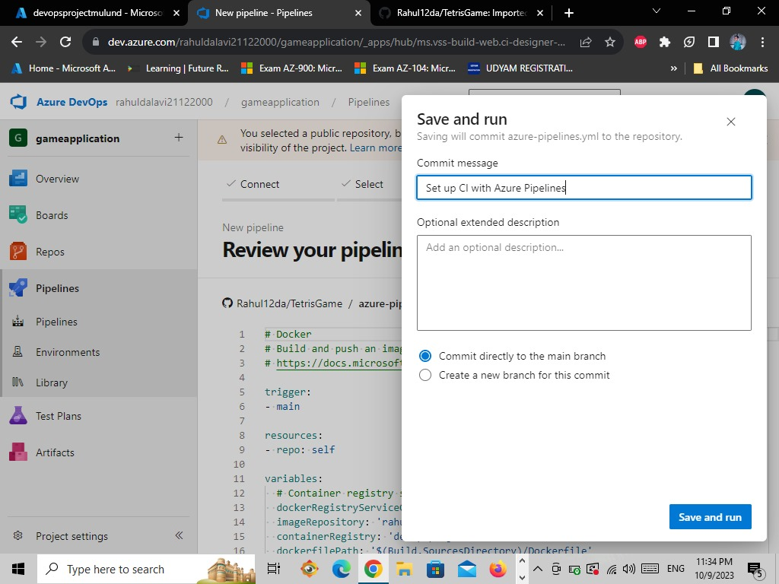

* **Now the pipeline is successfully created but the Job is incomplete so we have to wait.**

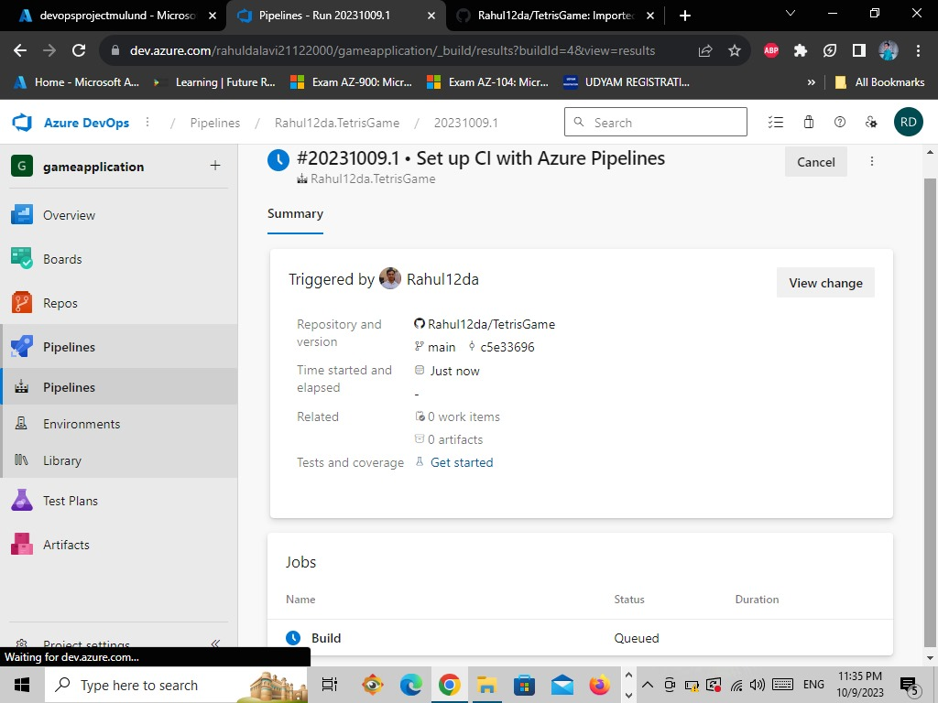

* **Now the Job is completed (the code is build and push).**

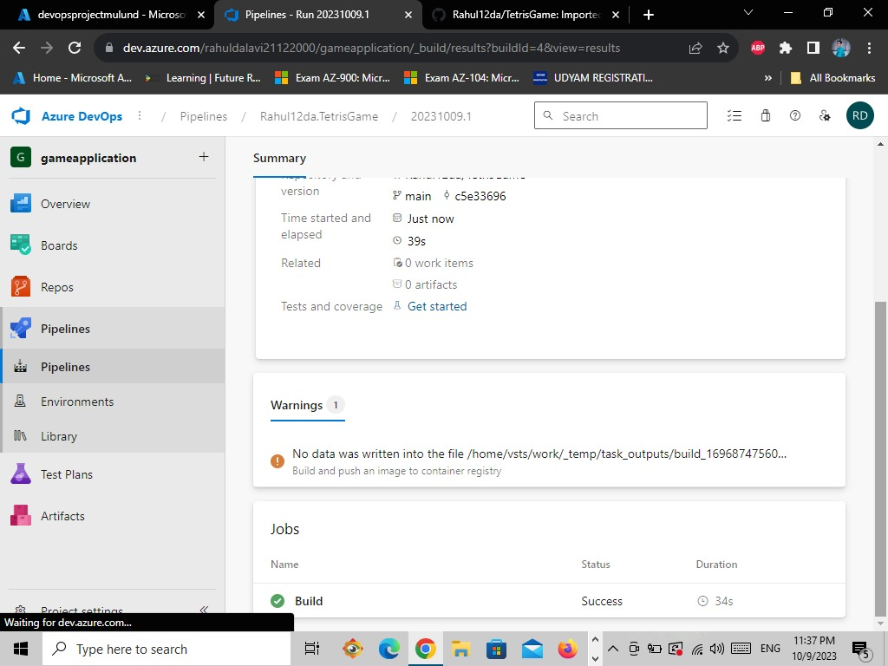

* **Click on Build Here you can see the the logs data**

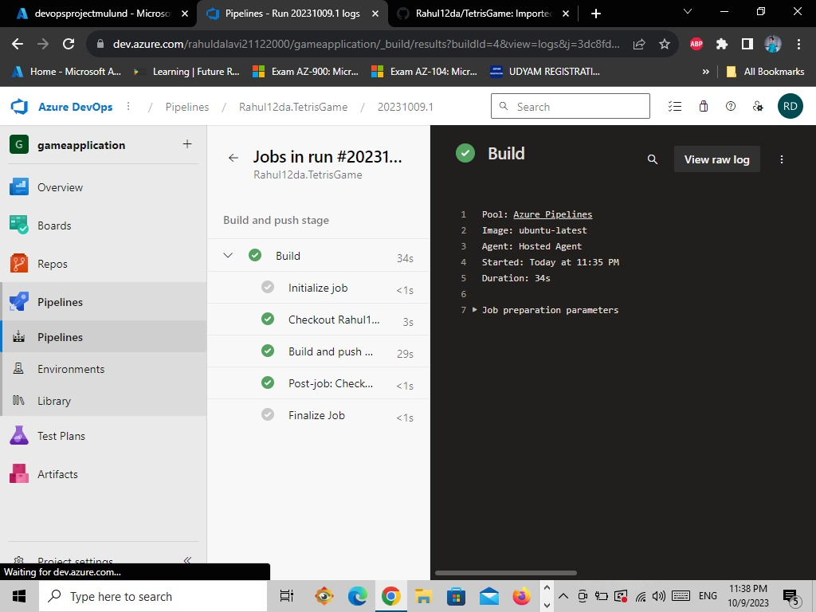

* **Now go to Azure Portal**

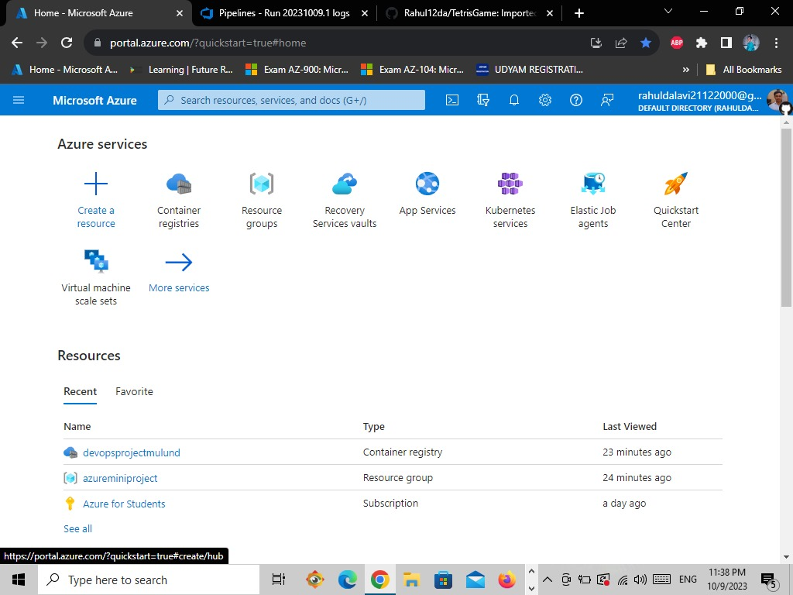

* **Go to Container registries**

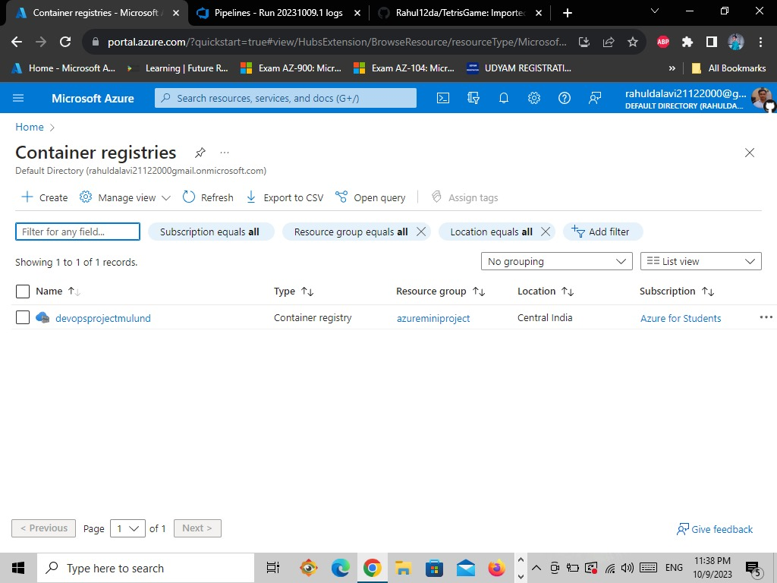

* **Open Container Registry**

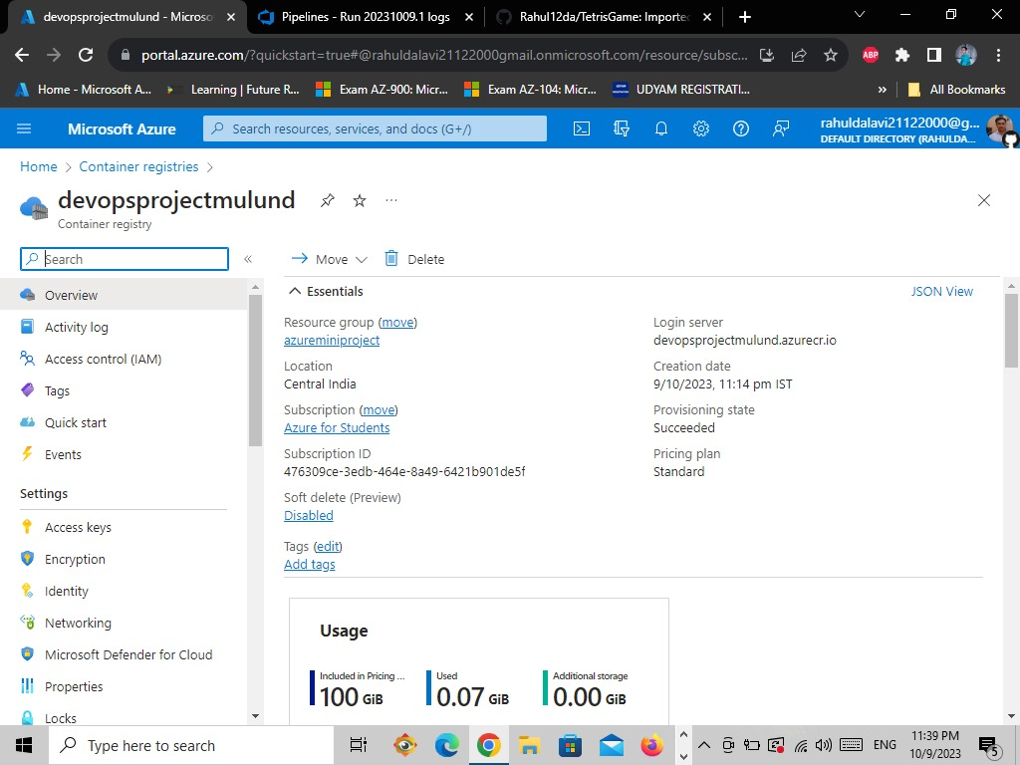

* **Go to the Access keys**

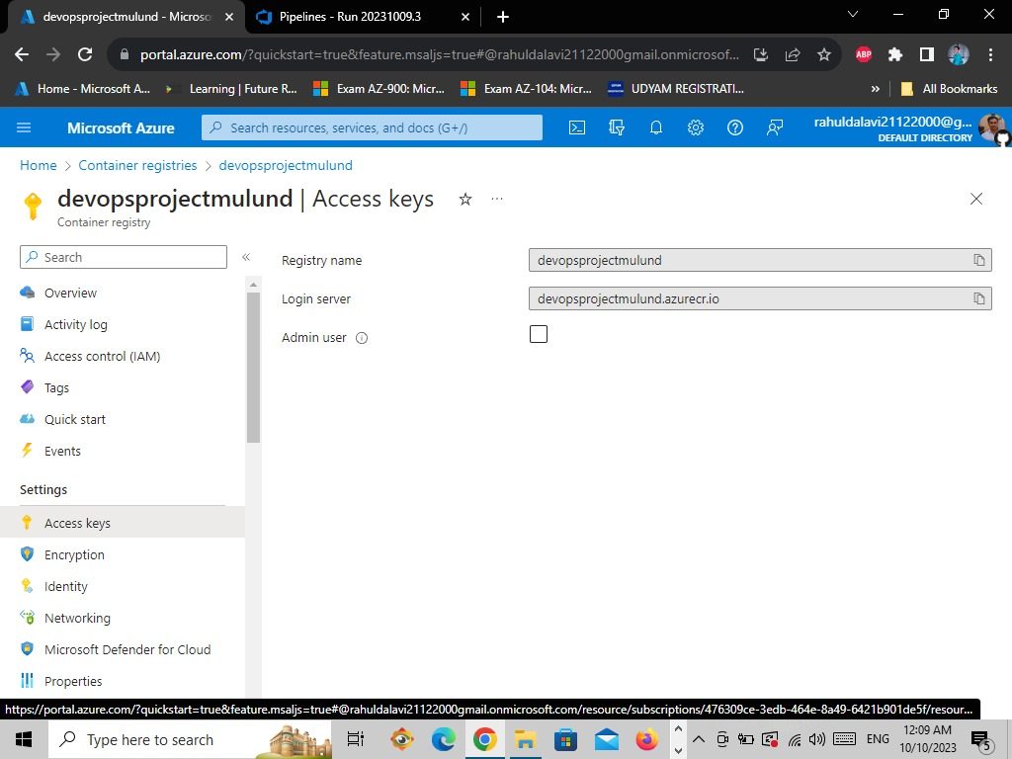

* **Click on the Admin user and You can see Successfully activated admin user**

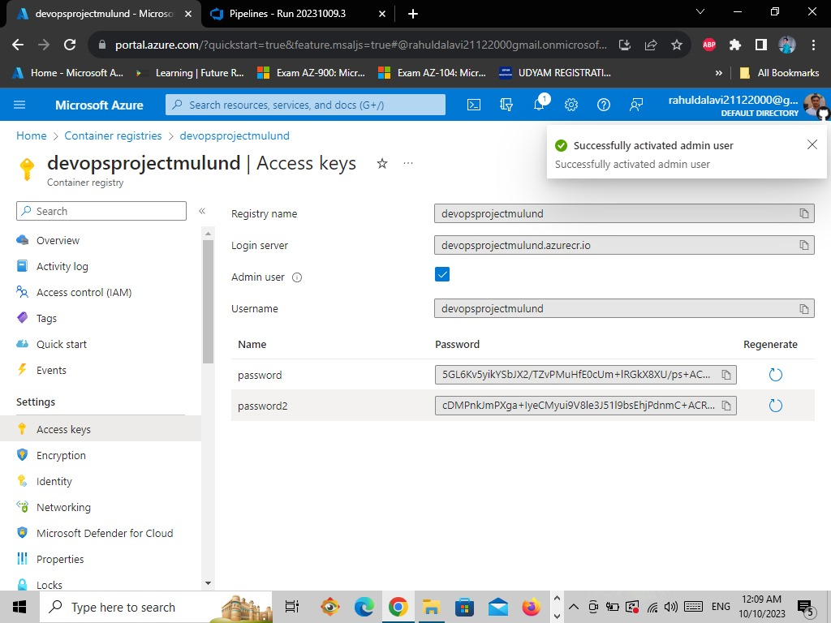

* **Go to the Azure portal Home**



* **Search for App Service and open**

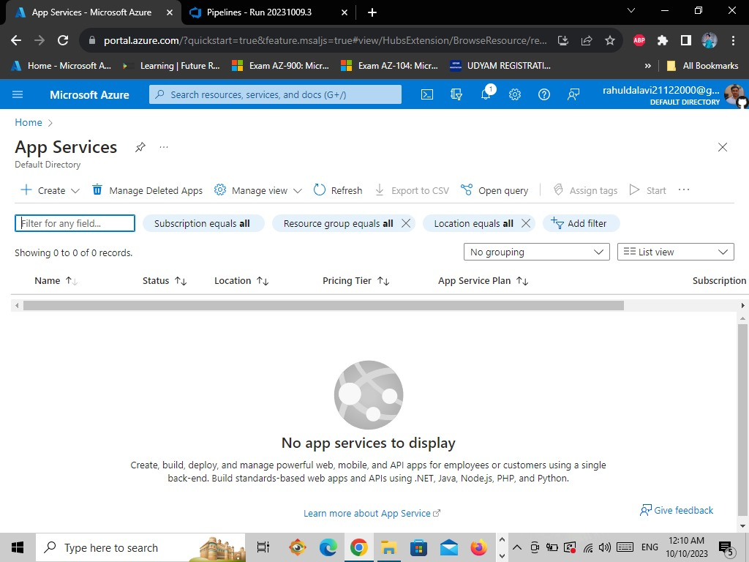

* **Click on Create Web App**

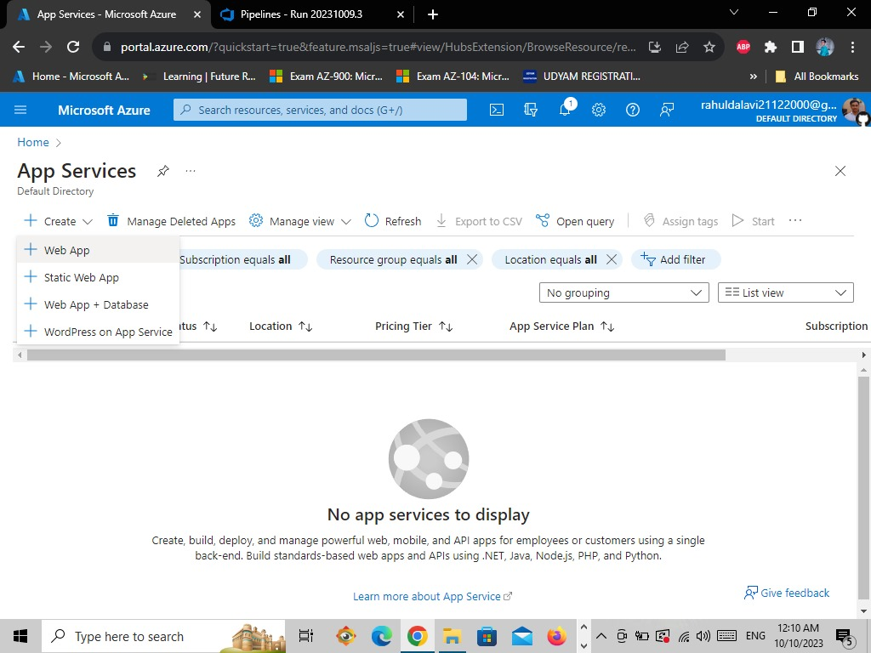

* **Enter the Resource Group name and the Web App name**

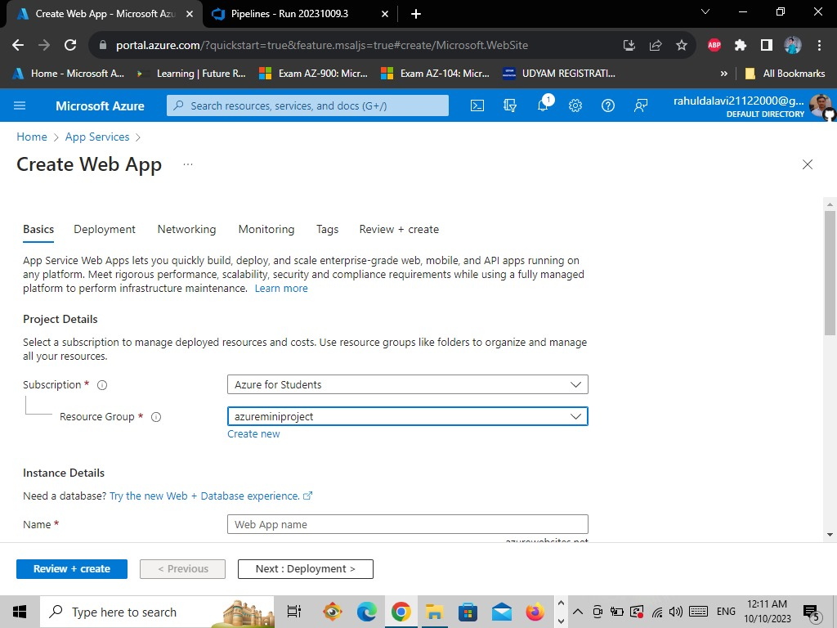

* **Select Docker container and select the Region**

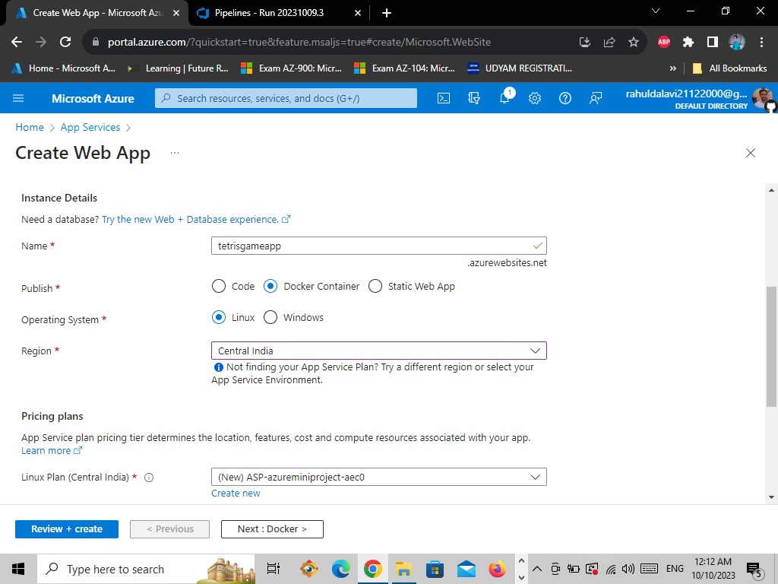

* **Select the Linux pricing plan as the Basic B1**

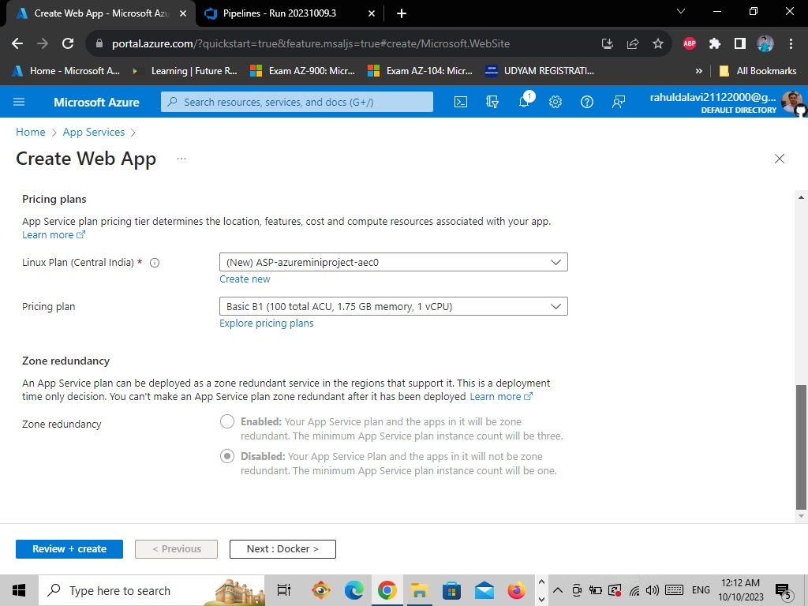

* **Now go to Docker tab and select Option>Single container, Image Source> Azure Container Registry, select Registry and Image**

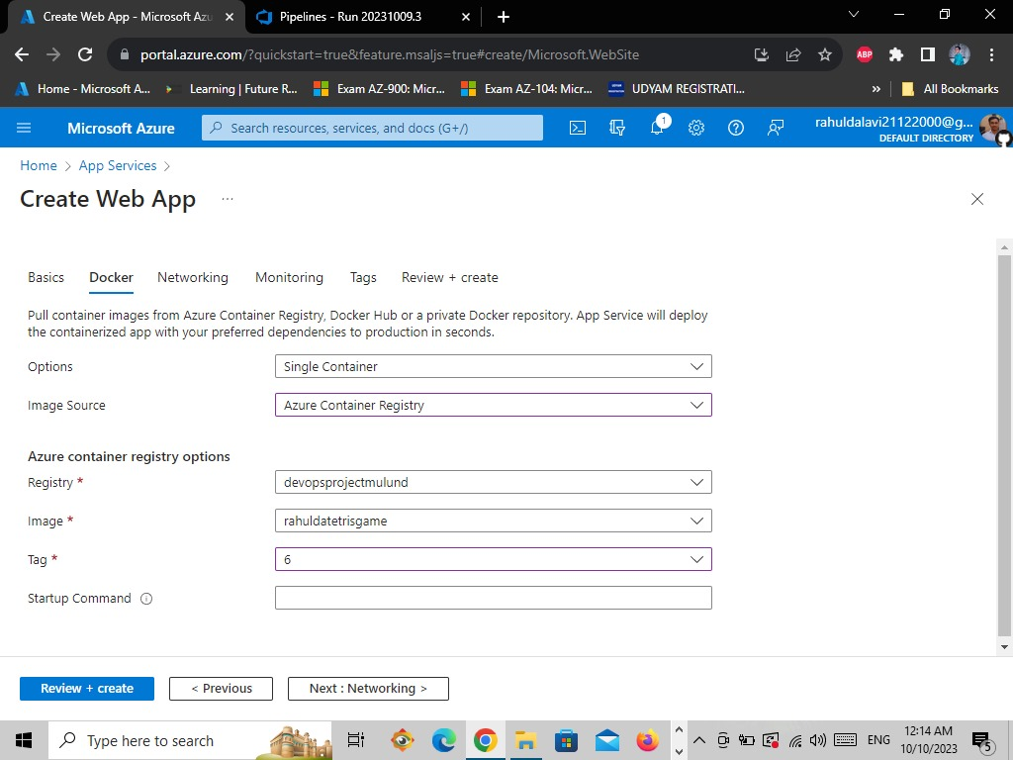

* **Tap on the Review and Create**

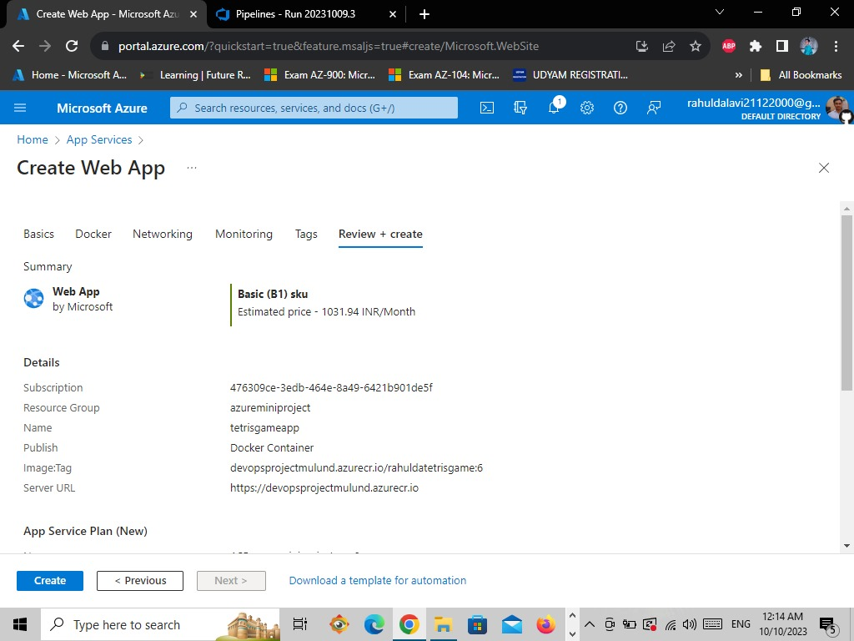

* **Here you can see the Web App is successfully deployed**

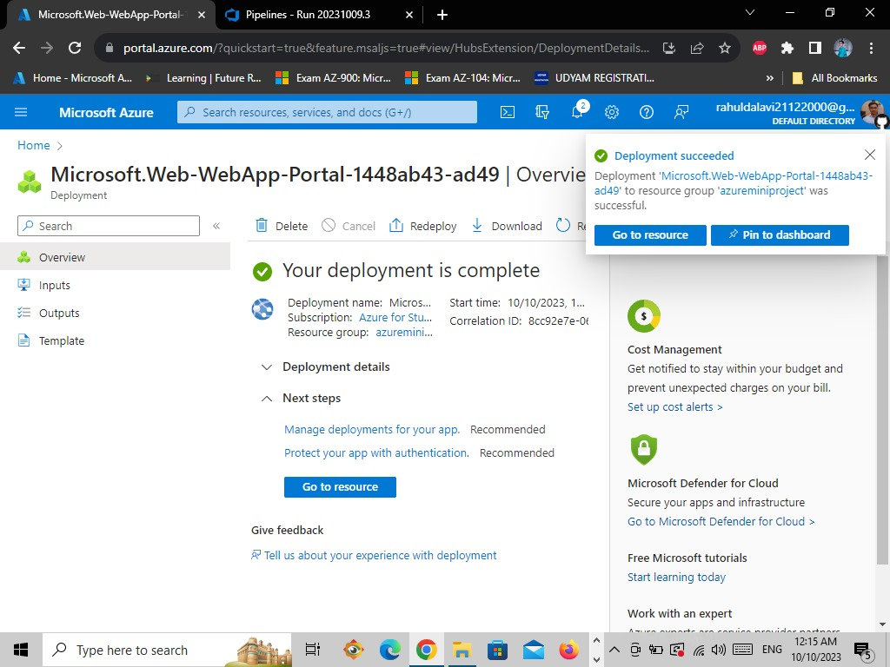

* **Click on Go to Resource**

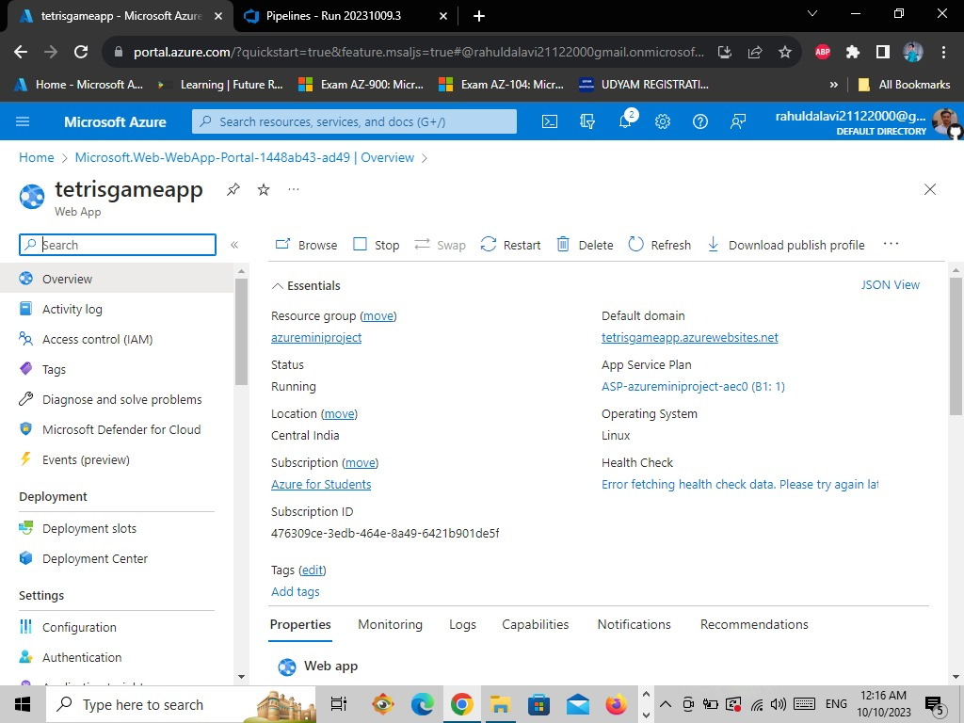

* **Now go the app Services and select the Tetrisgameapp**

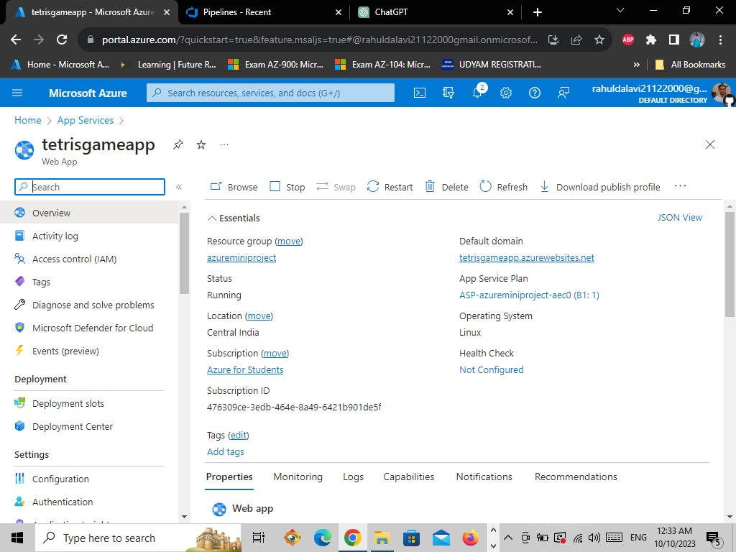

* **From the left side bar tap the Configuration**

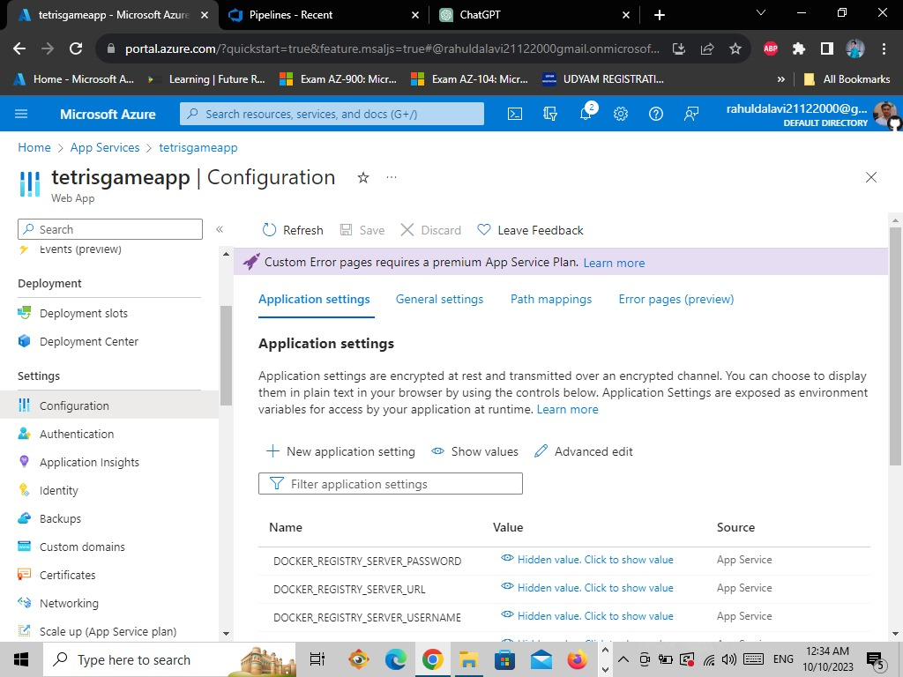

* **Then tap on the Application Setting and enter name as WebsitePort and value as 3000 and click on ok**

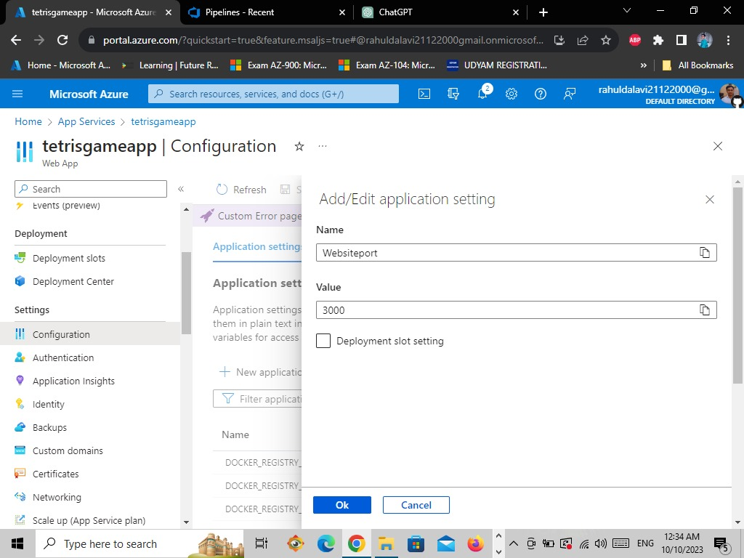

* **Save changes**

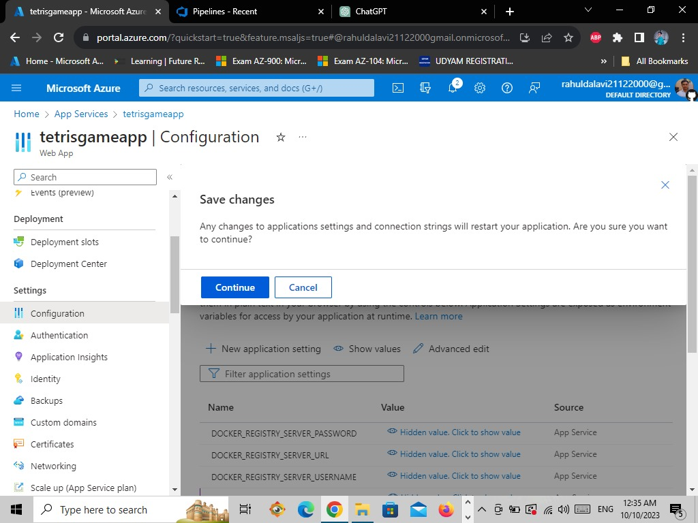

* **Go to Overview**

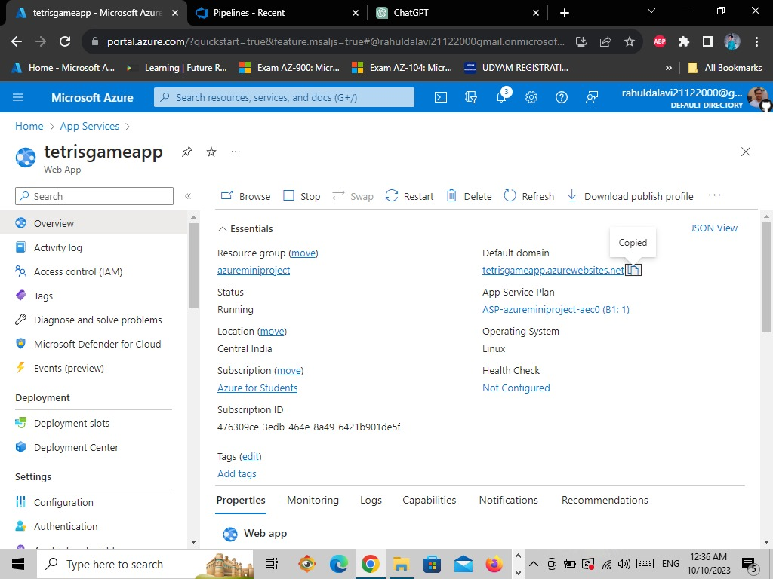

**Outputs:-**

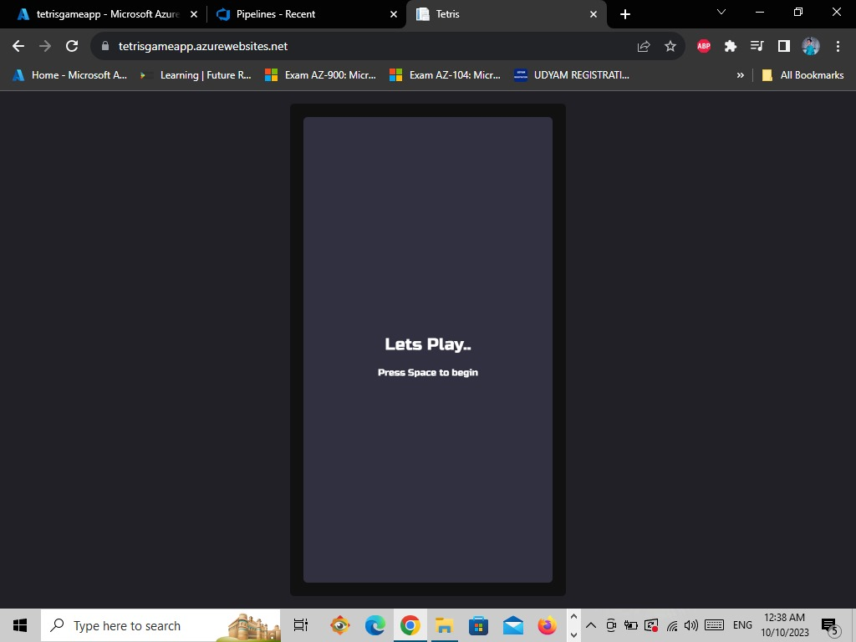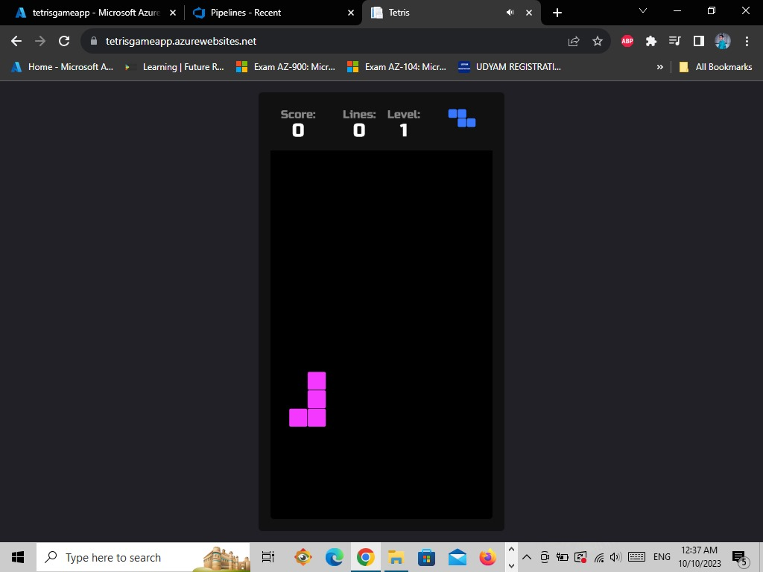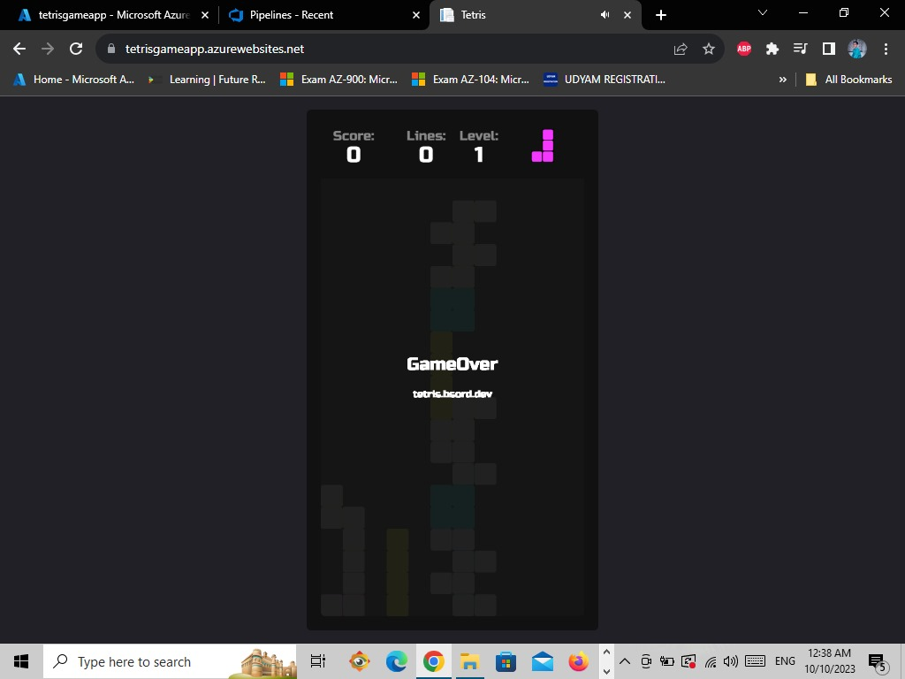

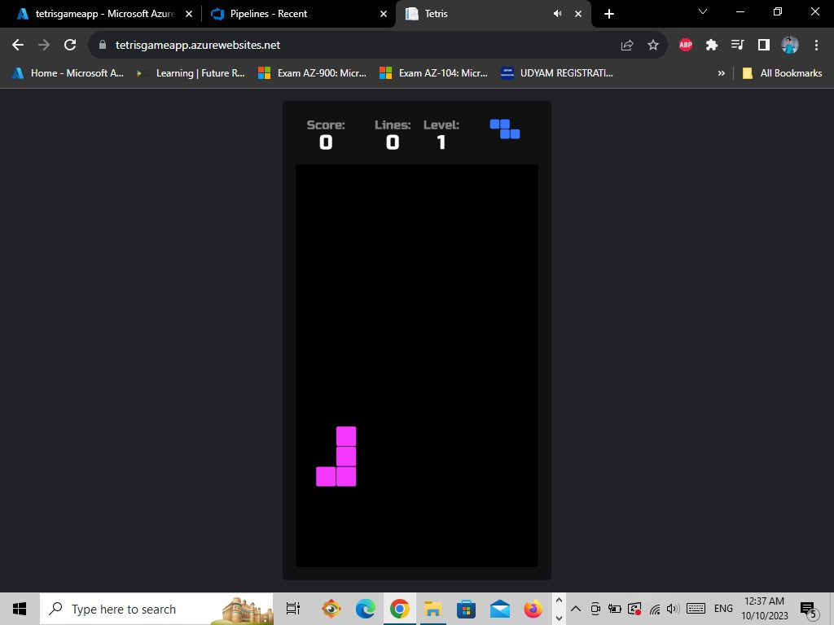

**Conclusion:-**

The Azure DevOps Tetris Game App project exemplified the effectiveness of utilizing Azure DevOps tools for end-to-end project management, development, and deployment. The agile workflow enabled efficient collaboration and adaptability throughout the development lifecycle. The successful deployment of the Tetris game app to production showcased the reliability and scalability of Azure DevOps pipelines. Ultimately, the project demonstrated how Azure DevOps can facilitate the creation of a well-structured, feature-rich Tetris game app, meeting both technical and user-centric requirements.